Request to implement OPHIR USBI-2 (Pulsar) in Master Control

# <https://drive.google.com/open?id=1dPzWk-l9irKi73dwhgT_kam2eYn2WzAG>

# What is it?

Pulsar-2 (P/N 7Z01202)

<http://www.ophiropt.com/laser--measurement/laser-power-energy-meters/products/PC-Interfaces/Pulsar-2?rel=related-product>

# What is it good for?

The USBI-2 connects to the Device PC/Server via USB. Energy meters connect to the USBI-2 (=Pulsar 2) via serial.

Read two energy meters measuring amplified beam transmitted through a 99% BS.

# Output:

The output of the measurement should be two numbers: the energy/power measured by each energy/power meters

Shot correlated data that can be logged along with other on-shot experiment data.

# Settings:

We need most settings we can have in Starlab3 (Fig. 1) for both of the energy meters.

In particular:

* Need to scan for the Pulsar-2 on the USB port before starting off
* External Trigger Boolean (on off, setable)
* Pulse width (that is of the measured pulse, setable in steps given by the energymeter)
* Energy range (given by the energy meter - probably is mostly a display setting)
* Wavelength (setable)
* Measurement Mode (Energy or power)
* Enable or disable single channels of the USBI-2 in case one of the energy meters is currently absent (e.g. due to RMA/calibration)

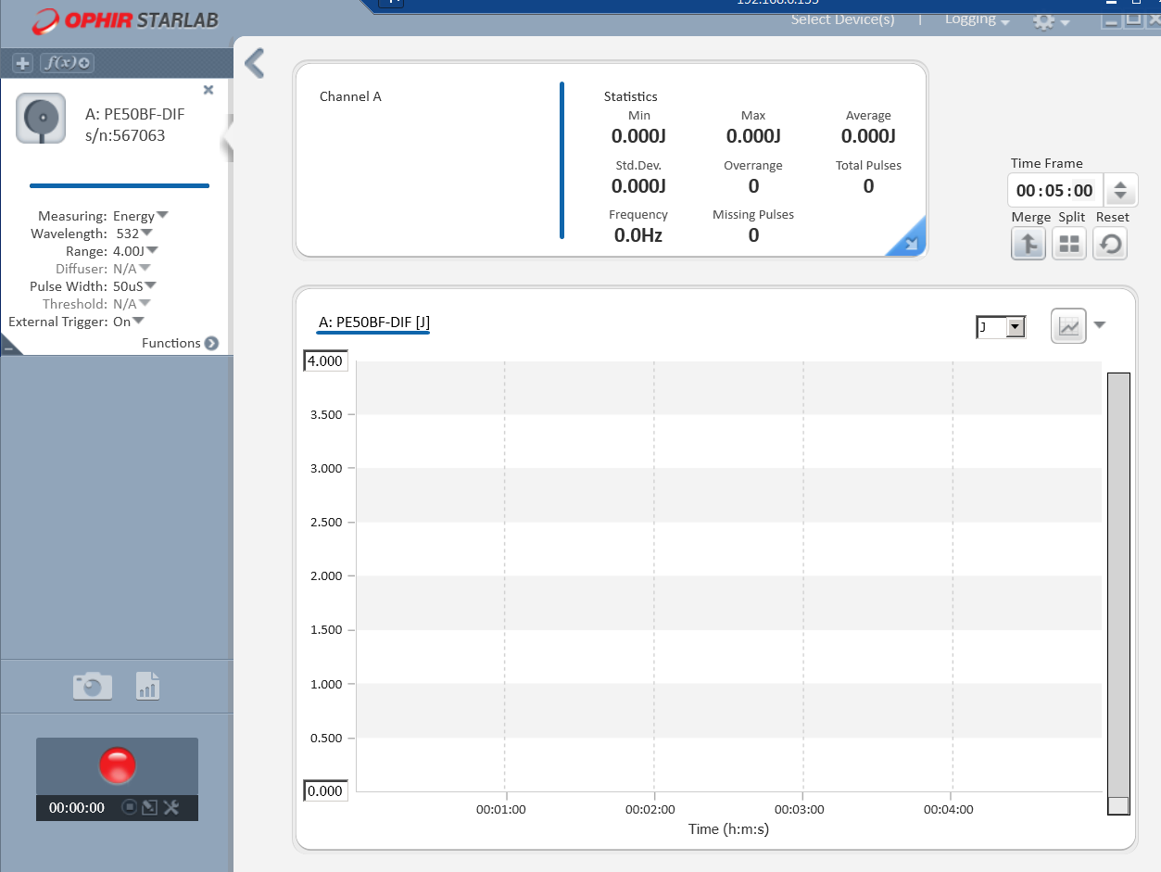

Fig. 1